Civil war in Rwanda

UNSC Resolution: | 935
Date of adoption: | 1 July 1994
Operative paragraph: | 5
Demand number: | 935.0511

Carla Winston

Wording of demand
Cooperate with the Commission of Experts in the accomplishment of its mandate, including responding positively to requests from the Commission for assistance and access in pursuing investigations

List of addressees of the demand
Interahamwe, Government of Rwanda, Rwandan Patriotic Front

Short-term compliance

Description of the addressee(s)’ conduct
11. During the Commission’s visit to Rwanda, the Government urged the Commission to conclude its work expeditiously and also urged that an international tribunal, along the lines of that organized for the former Yugoslavia, be created. The Government expressed the view that the trial of those accused of serious breaches of international humanitarian law and acts of genocide by an external impartial body would help promote peace and reconciliation among the parties and contribute to the stabilization of the situation in Rwanda. The Government has given assurances that it will make every effort to prevent summary trials, revenge executions and other acts of violence and that it will arrest those accused of such crimes.
…
14. The United Nations High Commissioner for Refugees sent a mission to Rwanda in August to assess how far conditions existed for the safe return to that country of refugees who had fled to Burundi, the United Republic of Tanzania and Zaire. In the course of its work, the mission of the Office of the United Nations High Commissioner for Refugees (UNHCR) obtained certain information that appeared to indicate that soldiers of the RPF might have been engaged in systematic killings of members of the majority community in Rwanda.
15. On 16 September, the High Commissioner briefed senior officials of the United Nations on the matter. On the basis of that briefing, I directed that the allegations should be immediately taken up with the Government of Rwanda. This was done by the Under-Secretary-General for Peace-keeping Operations, Mr. Kofi Annan, who was in Rwanda on mission at that time, and my Special Representative for Rwanda, Mr. Shaharyar Khan. The Government of Rwanda undertook to investigate the matter urgently and a team consisting of four government ministers, representatives of UNAMIR and UNHCR and a United Nations human rights monitor, paid a visit on 23 September to some of the places where the killings were alleged to have taken place. Those allegations have been reported to the Commission of Experts and to the Special Rapporteur and arrangements are now being made for a thorough investigation to be carried out under the mandate of those two mechanisms.
(Progress Report of the Secretary-General on the United Nations Assistance Mission for Rwanda, UN Doc. S/1994/1133 (6 October 1994), par. 11, 14-15)

15. During its stay in Rwanda, the Commission carried out a number of missions in the field and initiated several investigations. It also had the opportunity to hold a number of meetings with Rwandese refugees at Goma, Zaire, and at Dar-es-Salaam and to collect allegations of violations committed by the Rwandese Patriotic Front (RPF).
25. The Commission made visits to Nyamirambo (Kigali), Nyarubuye, Gafunzo, Gikondo, Cyanvuzo, Save, M’bazi, Ntarama and a number of other sites of atrocities. The Commission was received by the Minister of the Interior, the Minister of Justice, the Prime Minister and the Vice-President, General Paul Kagame.
(Final report of the Commission of Experts established pursuant to Security Council resolution 935 (1994), UN Doc. S/1994/1405 Annex (9 December 1994), par. 25)

Assessment

Short-term compliance
No or marginal compliance (1) | Medium low compliance (2) | Medium high compliance (3) | Full or almost full compliance (4)

Considerations underlying the assessment
The primary parties are/is the RPF-controlled Government of Rwanda, which gave as much help as it could, barring minimal evidence of RPF violations. The Interahamwe was only partially compliant, giving evidence about RPF violations, but is not the primary addressee.

Medium-term compliance

Description of the addressee(s)’ conduct
(The Commission finished its work within the initial six-month period after the demand was made, so there was no compliance to be had in the medium term.)

Assessment

Medium-term compliance
No or marginal compliance (1) | Medium low compliance (2) | Medium high compliance (3) | Full or almost full compliance (4)

Considerations underlying the assessment
(The Commission finished its work within the initial six-month period after the demand was made, so there was no compliance or non-compliance to be had in the medium term.)

Depth of demand

Assessment

Level of depth of demand
Low depth of demand (1) | Medium depth of demand (2) | High depth of demand (3)

Considerations underlying the assessment
Any possible revelations by the Commission about particular atrocities committed by the Government of Rwanda (at the time controlled by the genocidaires) or the RPF would not have negatively impacted the ability of the RPF to keep its control of the government of Rwanda.

Level of confidence about coding decisions

Level of confidence about coding decision
Extremely high | High | Moderate

Comments to IPI (if any)

The “moderate” confidence is because I really didn’t know what to do with the medium-term assessment: there was no compliance needed, because the Commission ceased to work with its final report on 9 December, not quite 6 months after the demand. If you like, you can change the answer to “not compliant,” but really this entry should just be removed from the database.

Civil war in Rwanda

UNSC Resolution: | 955
Date of adoption: | 8 November 1994
Operative paragraph: | 2
Demand number: | 955.0211

Carla Winston

Wording of demand

Cooperate fully with the International Tribunal and its organs in accordance with the present resolution and the Statute of the International Tribunal and that consequently all States shall take any measures necessary under their domestic law to implement the provisions necessary of the present resolution and the Statute, including the obligation of States to comply with requests for assistance or orders issued by a Trial Chamber under Article 28 of the Statute, and keep the Secretary General informed of such measures

List of addressees of the demand

Government of Rwanda

Short-term compliance

Description of the addressee(s)’ conduct

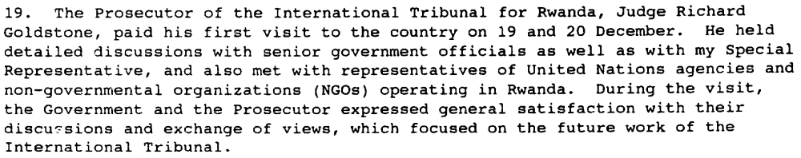
Progress Report of the Secretary-General on the United Nations Assistance Mission for Rwanda, UN Doc. S/1995/107 (6 February 1995), par. 19, 48)

8. Government officials explained their concerns with regard to the International Tribunal for Rwanda, but reaffirmed Rwanda’s readiness to cooperate with the Tribunal and expressed the hope that it would begin its work as soon as possible. (Report of the Security Council Mission to Rwanda on 12 and 13 February 1995, UN Doc. S/1995/164 (28 February 1995), par. 8)

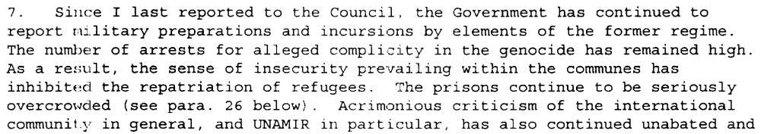
(Report of the Secretary-General on the United Nations Assistance Mission for Rwanda, UN Doc. S/1995/457 (4 June 1995), par. 7)

Assessment

Short-term compliance
No or marginal compliance (1) | Medium low compliance (2) | Medium high compliance (3) | Full or almost full compliance (4)

Considerations underlying the assessment

Compliance, but with expressed concerns and lack of capacity to deal with the enormous potential caseload of persons complicit in genocide.

Medium-term compliance

Description of the addressee(s)’ conduct
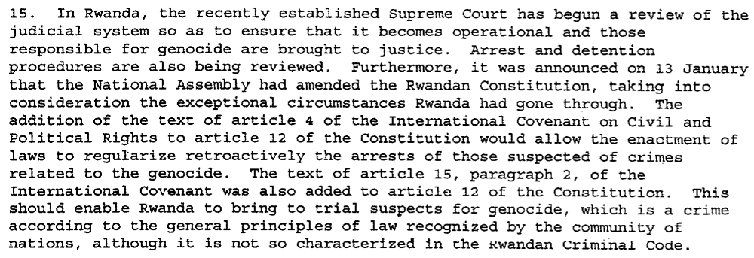(Progress Report of the Secretary-General on the United Nations Assistance Mission for Rwanda, UN Doc. S/1996/61 (30 January 1996), par. 15)

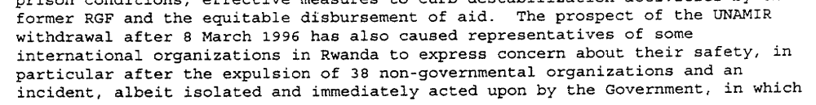
(Report of the Secretary-General on the United Nations Assistance Mission for Rwanda, UN Doc. S/1996/149 (29 February 1996), par. 3)

“Although the ICTR was initially created at Rwanda’s request, the numerous conditions imposed by the Security Council - refusal of the death penalty, headquarters outside Rwanda, foreign judges and prosecutors, a mandate that excludes pre-1994 events, a shared prosecutor with the ICTY, primacy over national courts, etc, - meant that Rwanda was the only country to vote against the establishment of the ICTR on 8 November 1994. Clearly, the ICTR cannot operate without being allowed access to witnesses, and access to the country is crucial for gathering evidence. Since 1994, the position taken by the Rwandan government has swung between this original opposition and more or less support depending on the circumstances.”
(International Criminal Tribunal For Rwanda: Delayed Justice. ICG Africa Report N° 30, 7 June 2001. p. 19. http://www.crisisgroup.org/library/documents/report_archive/A400442_02102001.pdf)

Assessment

Medium-term compliance
No or marginal compliance (1) | Medium low compliance (2) | Medium high compliance (3) | Full or almost full compliance (4)

Considerations underlying the assessment
Compliance, but slow and/or reluctant based on what Rwanda felt were unreasonable conditions. Some requests, such as making changes in Rwanda’s own judicial structure, were complied with, but one major failure of compliance was the supply of information about possible crimes by the RPF.

Depth of demand

Assessment

Level of depth of demand
Low depth of demand (1) | Medium depth of demand (2) | High depth of demand (3)

Considerations underlying the assessment
Complete compliance would have meant supplying the ICTR with evidence of RPF crimes, which could have led to the indictment and imprisonment of some of its leaders.

Level of confidence about coding decisions

Level of confidence about coding decision
Extremely high | High | Moderate

Comments to IPI (if any)

Civil war in Rwanda

UNSC Resolution: | 965
Date of adoption: | 30 November 1994
Operative paragraph: | 4
Demand number: | 965.0411

Carla Winston

Wording of demand
Continue its cooperation with UNAMIR in the implementation of its mandate and in particular in ensuring unimpeded access to all areas of Rwanda by UNAMIR forces, personnel of the International Tribunal for Rwanda, and human rights officers

List of addressees of the demand
Government of Rwanda

Short-term compliance

Description of the addressee(s)’ conduct
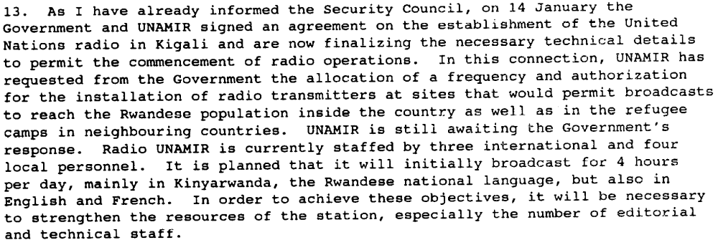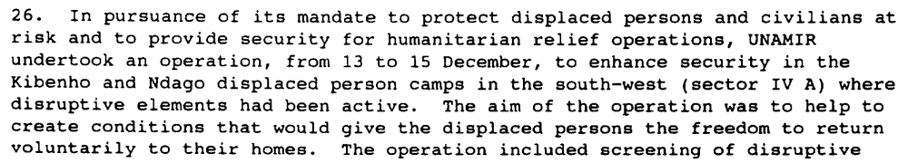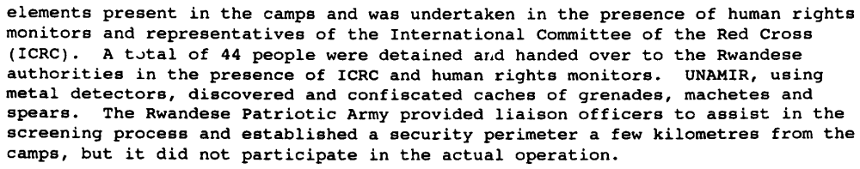
Progress Report of the Secretary-General on the United Nations Assistance Mission for Rwanda, UN Doc. S/1995/107 (6 February 1995), par. 13, 26, 48)

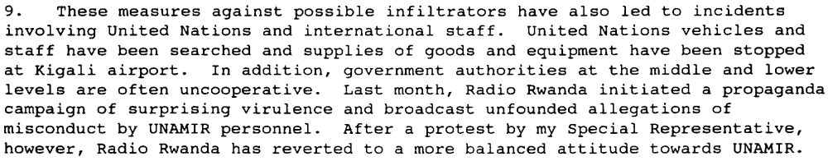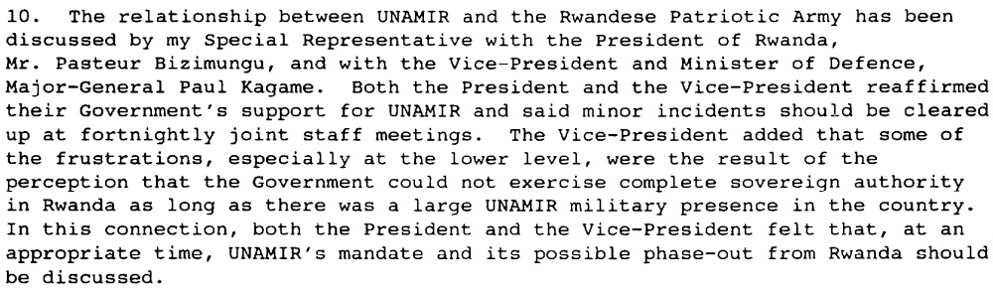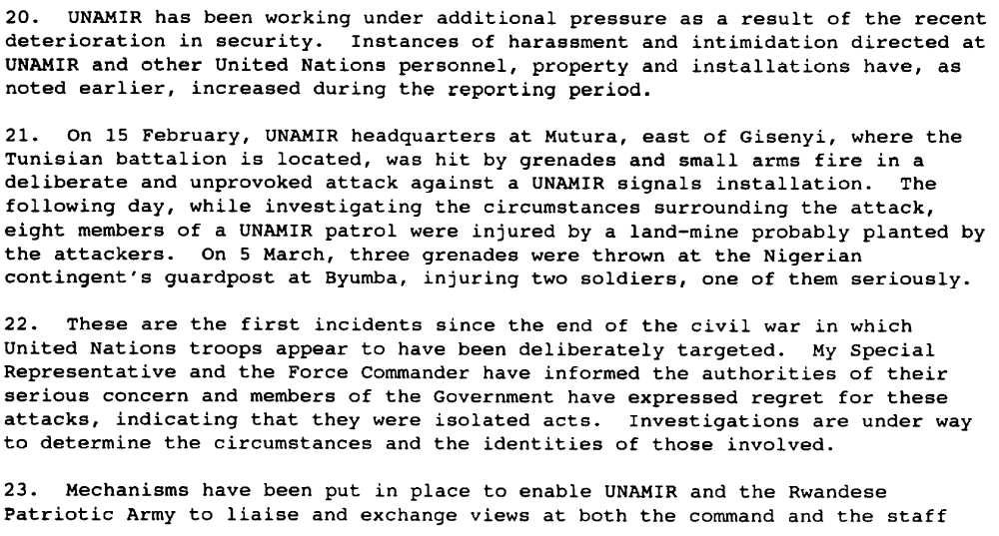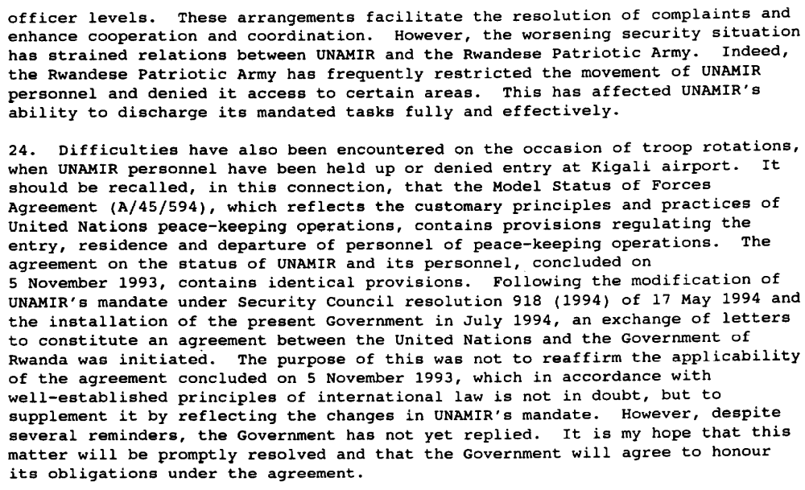
(Progress Report of the Secretary-General on the United Nations Assistance Mission for Rwanda, UN Doc. S/1995/297 (9 April 1995), par. 9-10, 20-25, 48)

Assessment

Short-term compliance
No or marginal compliance (1) | Medium low compliance (2) | Medium high compliance (3) | Full or almost full compliance (4)

Considerations underlying the assessment
Frequent problems in unimpeded access to the whole of Rwanda, including searching vehicles, holding up troop rotations, increasing harassment of staff, etc.

Medium-term compliance

Description of the addressee(s)’ conduct

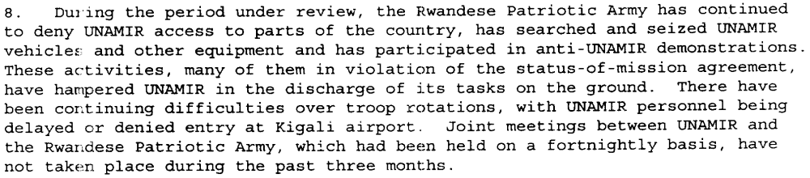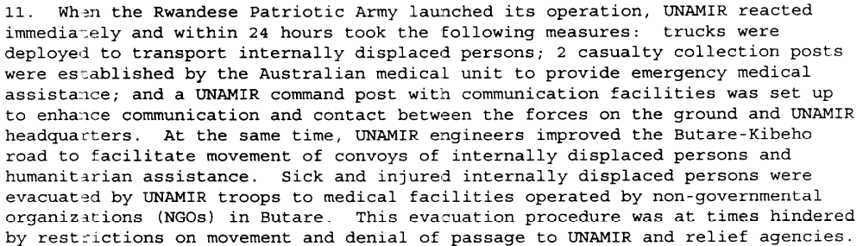…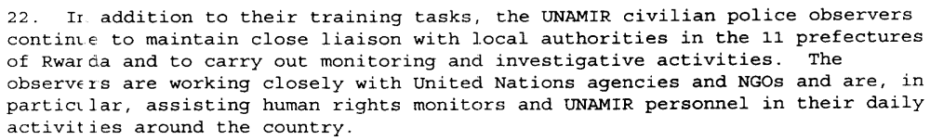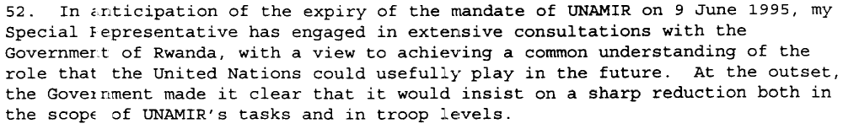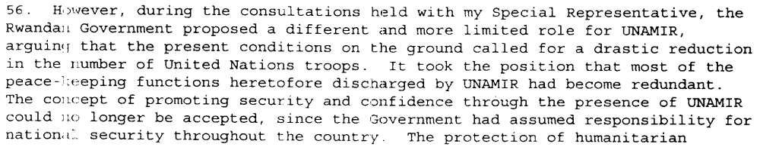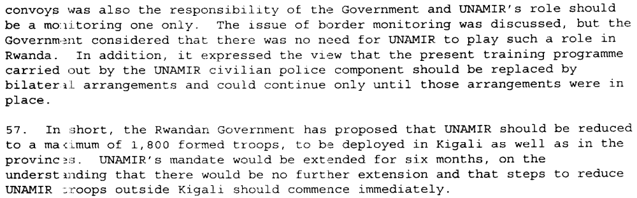
(Report of the Secretary-General on the United Nations Assistance Mission for Rwanda, UN Doc. S/1995/457 (4 June 1995), par. 7, 8, 11, 22, 52, 56, 57)

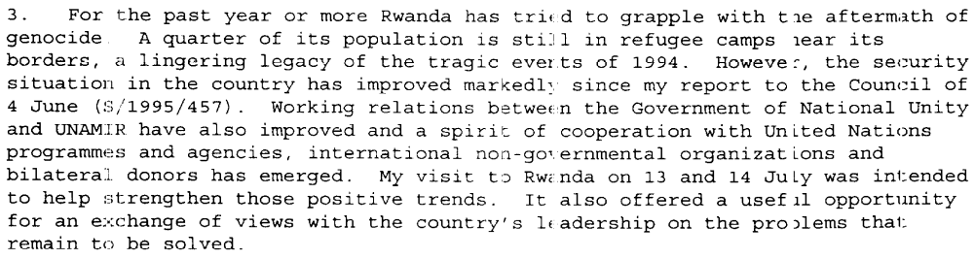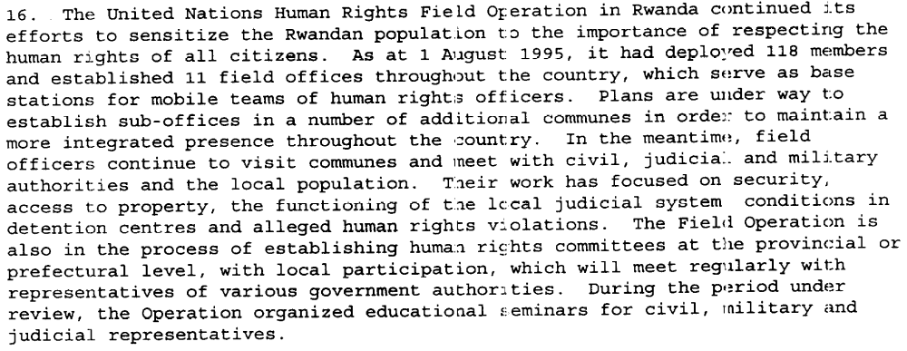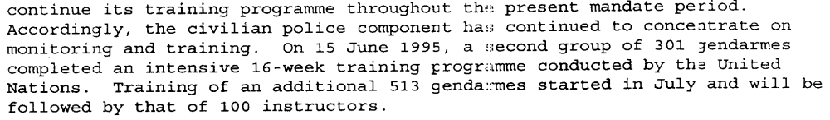
Report of the Secretary-General on the United Nations Assistance Mission for Rwanda, UN Doc. S/1995/678 (8 August 1995), par. 3, 11, 16, 24)

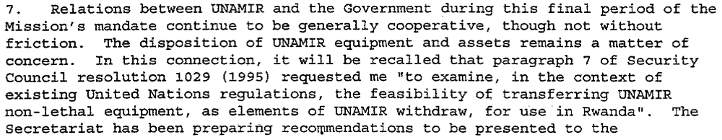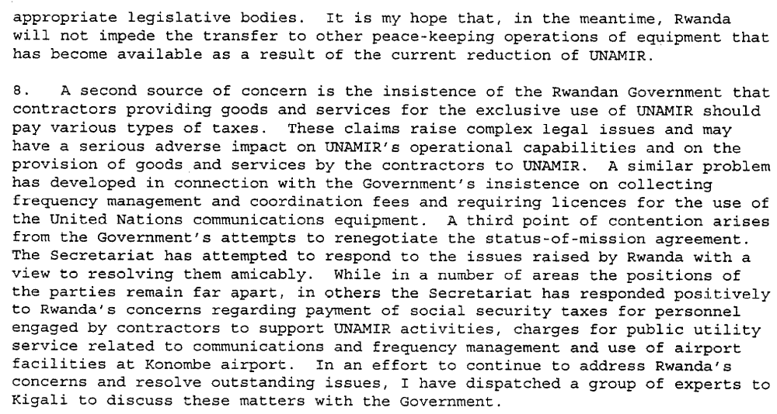
Progress Report of the Secretary-General on the United Nations Assistance Mission for Rwanda, UN Doc. S/2996/61 (30 January 1996), par. 7-8)

Assessment

Medium-term compliance
No or marginal compliance (1) | Medium low compliance (2) | Medium high compliance (3) | Full or almost full compliance (4)

Considerations underlying the assessment
Improved relations based on UNAMIR’s mission parameters changing to better suit the demands of the Government of Rwanda. Certain issues remained, especially with contractors and the modalities of UNAMIR’s future final withdrawal, as well as sporadic incidents in denial of access and harassment.

Depth of demand

Assessment

Level of depth of demand
Low depth of demand (1) | Medium depth of demand (2) | High depth of demand (3)

Considerations underlying the assessment
Certain actions proposed by UNAMIR could have had an adverse effect on Rwandan security, especially as regards attacks from the former Government of Rwanda across the Zairian border.

Level of confidence about coding decisions

Level of confidence about coding decision
Extremely high | High | Moderate

Comments to IPI (if any)

